**Saint Brigid Saint John the Baptist**

24th Sunday in

Ordinary Time

September 16, 2018

**Catholic Church Catholic Church**

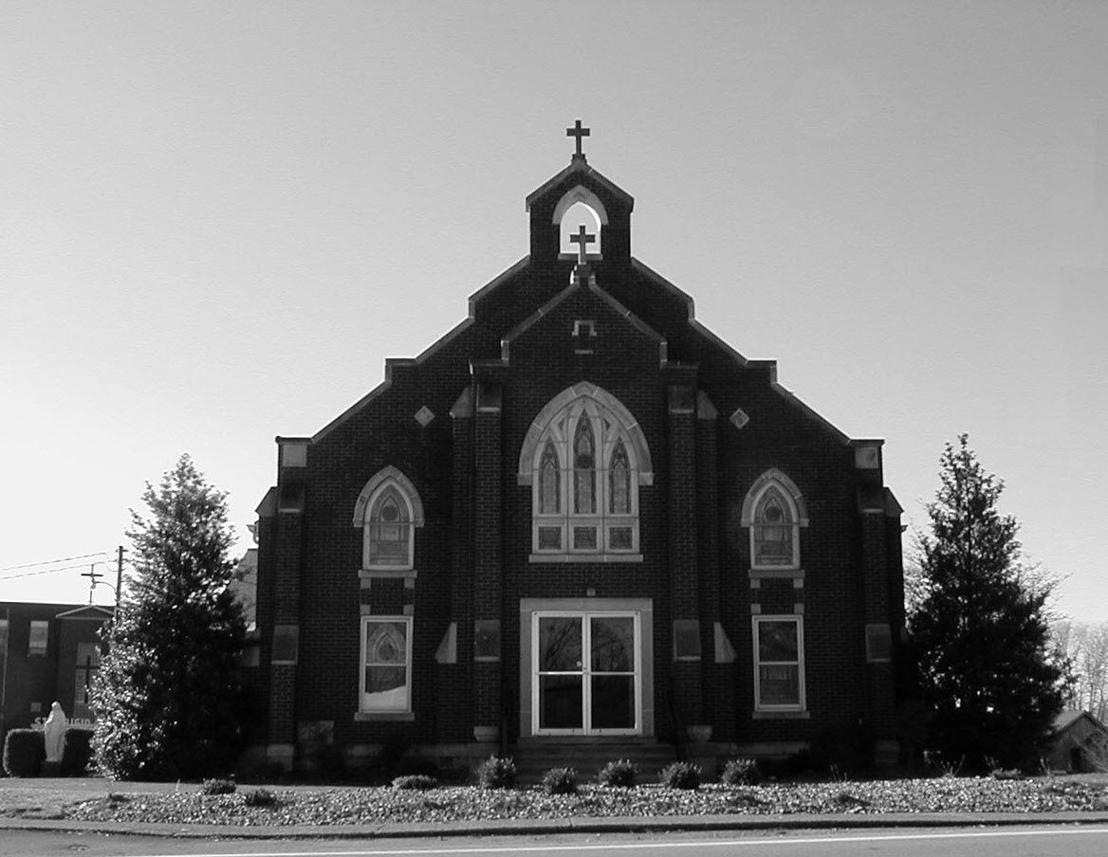

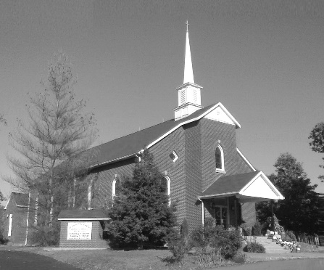

**Pastor:**

***Rev. Daniel L. Lincoln***

Rectory: (270) 877-2546

**Deacon:**

***Michael A. Ryan***

(270) 272-6789

314 E. Main St. 657 St. John Church Rd.

Vine Grove, KY 40175 Elizabethtown, KY 42701

Clustered Parish Office: Clustered Parish Office:

(270) 877-2461 (270) 877-2461

**ANNOINTING OF THE SICK:**

Notify the parish office when a family member is hospitalized.

**BAPTISM:**

Contact the parish office for information about the required preparation class.

**BULLETIN:**

Information must be submitted in writing by note or email to the parish office **no later than 12:00 noon on Wednesdays** for the following weekend. When sending an email, please put “BULLETIN,” and the name of the parish the announcement is for, in the subject line.

**MARRIAGE:**

Contact Father at least 6 months prior to the wedding date to complete required marriage preparations and to schedule the date.

**RCIA (Rite of Christian Initiation of Adults):**

Contact the Worship Chairperson for information.

**DEW MEMORIAL LIBRARY:**

(in St. Brigid Church basement):

Open: Sunday after 9:30 a.m. Mass& 45 minutes before all other Masses.

Email: [brigidvg@bbtel.com](mailto:brigidvg@bbtel.com) **Dir. of Religious Education:**

Website: [www.stbrigidvg.org](http://www.stbrigidvg.org)Lisa Thomas: (270) 735-6930

**Pastoral Associate & Dir. Youth Ministers:**

**of Religious Education:** Angela Churchman:

Deacon Mike Ryan: (270) 877-0546 (270) 268-9963

**Youth Minister:** Ericka Finlay: (502) 612-2644

Lori Law: (270) 723-0157

**MASS SCHEDULE:**

*Saturday (Vigil):*  6:30 p.m.

*Sunday:* 11:30 a.m.

*Wednesday:* 6:30 p.m.

*Friday:* 9:00 a.m.

**RECONCILIATION:**

Saturday before Mass

5:30-6:00p.m. or by appt.

**PARISH COUNCIL MEMBERS:**

*President:* Lauran Thomas

*Secretary:* Theresa Smith

**CHAIRPERSONS:**

*Administration:*  Nick Thomas

*Formation:* Ericka Finlay

*Parish Life:* Bradley Wickersham

*Worship:* Greg Thompson



**MASS SCHEDULE:**

*Sunday:* 9:30 a.m. & 6:30 p.m.

*Monday:* 9:00 a.m.

*Thursday:* 9:00 a.m.

**RECONCILIATION:**

Sunday before Mass

5:30-6:00 p.m. or by appt.

**ROSARY:**

After weekday Masses

**PARISH COUNCIL MEMBERS:**

*President:* Sue Weisshaupt

*Vice-President:* Mike Bramlett

*Secretary:* Judy Cochran

*At-Large Members:* Blake Ryan

& Vincent Thompson

**CHAIRPERSONS:**

*Administration:* Dale Winchester

*Formation:* Tina Yates

*Parish Life:* Tom Billings

*Worship:* Keith Baughman

**Mass Schedule**

**Mass Schedule**

|  |  |  |  |  |  |
| --- | --- | --- | --- | --- | --- |
| **Saturday** | **September 15** | **6:30 p.m.** | **St. John** | **For All Parishioners** | **Vigil: 24th Sunday in Ordinary Time** |
| **Sunday** | **September 16** | **9:30 a.m.** | **St. Brigid** | **Wilson & Frances Hunt**  **Mack, Leanna, Billy Cecil** | **24th Sunday in Ordinary Time** |
| **“** | **“** | **11:30 a.m.** | **St. John** | **Eric Yates** | **“** |
| **“** | **“** | **6:30 p.m.** | **St. Brigid** | **Our Parish Family**  **James William & Ella Winchester** | **“** |
| **Monday** | **September 17** | **9:00 a.m.** | **St. Brigid** | **Dickie Cecil**  **Candace Hicks** | **Weekday** |
| **Wednesday** | **September 19** | **6:30 p.m.** | **St. John** | **Fr. Stan Osborne** | **Weekday** |
| **Thursday** | **September 20** | **9:00 a.m.** | **St. Brigid** | **Richard Hughes**  **Carlos Robbins** | **St. Andrew Kim Tae-gon, Priest & Paul Chong Ha-sang, and Companions, Martyrs** |
| **Friday** | **September 21** | **9:00 a.m.** | **St. John** | **Brad French** | **St. Matthew, Apostle** |
| **Saturday** | **September 22** | **6:30 p.m.** | **St. John** | **Bruce & Margaret Lincoln** | **Vigil: 25th Sunday in Ordinary Time** |
| **Sunday** | **September 23** | **9:30 a.m.** | **St. Brigid** | **Richard Hughes**  **Bill Brown** | **25th Sunday in Ordinary Time** |
| **“** | **“** | **11:30 a.m.** | **St. John** | **For All Parishioners** | **“** |
| **“** | “ | **6:30 p.m.** | **St. Brigid** | **Our Parish Family**  **Harold Yates** | **“** |

**INFORMATION FOR BOTH PARISHES**

**PYX** – If anyone has a pyx they are no longer using, please turn them in to Father Dan. They are needed for the hospital ministers.

**ABORTION AND ADOPTION –** The number of would-be adoptive parents (of newborn babies) far outstrips the supply in America. Each year in the United States, about 135,000 American children are placed for adoption. Experts estimate somewhere between one and two million couples seek to adopt yearly. Every year, there are about 1.3 million abortions. Sadly, only 4% of women with unwanted pregnancies give their children up for adoption. Every child is wanted and wanted desperately! By Pro-Life Articles Author [www.pro-lifearticles.org](http://www.pro-lifearticles.org)

**PROJECT RACHEL** **–** Healing…Forgiveness…Hope…After the experience of an abortion. If you or someone you know is struggling with the pain from an abortion, please consider Project Rachel – a post abortion ministry. To speak to someone confidentially, call (502) 471-2155 or email [ProjectRachel@archlou.org](mailto:ProjectRachel@archlou.org).

**CONFIDENTIAL PREGNANCY AND ADOPTION COUNSELING** – is available at Catholic Charities for women of all ages experiencing untimely pregnancies. A full range of services are provided, including adoptive placement, legal assistance and counseling for individuals, groups and families. Post-abortion counseling is also available. Services are provided regardless of income or marital status. For more information, call Catholic Charities at (502) 637-9786.

**OPPORTUNITIES FOR LIFE TRAINING** – Opportunities for Life (OFL), a ministry of the Kentucky Catholic Bishops, serving women, men, and families dealing with untimely pregnancies, will be offering a volunteer training workshop at Saint Athanasius Paris, 5915 Outer Loop, Louisville, on **Thursday, September 27, from 10:00 a.m. to 5:00 p.m.** (Lunch will be provided.) OFL volunteers offer hope, compassion, options, counseling, and resources to callers who find the courage to seek help, and volunteers are needed to staff the 24 hour helpline from their homes. Attendees for the training workshop must register in advance. If you have a heart for life affirming ministry, please call (888) 496-3638 to learn more about this ministry and the upcoming training workshop.

* * * * * * * * * * * * * * * * * * *

**St. John and St. Brigid Prayer List**

To add someone to the prayer list, please call the parish office at (270) 877-2461. **Remember to call to remove someone from the list if they are no longer sick, etc.** *Please note that the prayer list has been revised. It is primarily for parishioners and their immediate family members*.

Leslie **Adams-Cerniglia**, Sam **Adams**, April **Allen**, Dennis **Arnold**, Barbara **Ashley**, Donnie Alan **Atcher**, Sue **Banks**, Shannon **Barnes,** Denise **Barnett**, Timothy **Birch**, Teresa **Blaycock**, Charlie **Bowers**, Pauline **Brangers**, Ellen **Bryan**, Richard **Bryson**, Carol **Buchanan**, Linda **Buchanan**, Jeremy & Margie **Buyer**, Deacon Bob **Caspar**, Sue **Caswell**, Ed **Cecil**, J. Mack **Cecil**, Steve **Cecil**, Harlan Ford **Clark**, Judy **Cleaver**, John **Connor**, Betty Jo **Cooper**, Heidi **Correa**, Jeff **Craig**, Glynn **Clutches**, Roan **Dowell**, Karen **Dworshak**, Leroy **Embry**, Marion **French**, Martha **Ford**, Dwayne **Garcia**, Carrie **Gribben**, Mary **Hager**, Mrs. Charles **Hair**, Stephanie **Hall**, Donnie **Hart**, Jimmy **Harper**, Bobby **Harris**, Eileen **Heinen**, Debbie **Hodge**, Betty Lou **Jones**, Charlene **Langley**, Olivia **Leasor**, Jenny **Leonhardt**, Jackie **Long**, Louise **Lucous**, Alma **Mahanna**, Shelly **Martin**, Shirley **Martin**, Martina **Masoni**, Don **Mattingly**, Gerard **Mattingly**, Paul Michael **Mattingly**, Mary **Medley,** Cindy **Miller**, Starla **Miller**, Doug **Osborne**, Duane **Osborne**, Mickey **Padgett**, Frank **Inanely**, Jerry **Phillips**, Annie **Pierce**, Adrianna **Porter**, Jeremy **Porter**, Adrian **Ray**, Allie **Ray**, Mary Agnes **Ray**, Mary Ellen **Ray**, Tonya **Reisinger**, Joel **Rivera**, Lelia Rose **Ryan**, Pat **Ryan**, Caroline **Seabee**, Leon **Skeeters**, Jim **Smith**, Ralph **Staples**, Keith **Tassin**, Anthony **Thomas**, Kenny **Thompson**, Raffaella **Tucker**, Debi **Turner**, Stacey **Vance**, Bill **Waldrop**, Lois **Weaver**, De Neil **Whelan**, Paul A. **Whelan**, Jennifer **Williams**, Sandy **Wiseman**, Zach **Wiseman**, Gail **Wilson**, Don **Wooldridge**, Connor **Wright**, and all the sick, both mentally and physically.

* * * * * * * * * * * * * * * * * * *

**Our Military List**

To add someone to the military list, please call the parish office at (270) 877-2461. **Remember to call to remove someone from the list if they are no longer in the service**.

Lt. Matt **Bednar**, PFC Richard H. **Chapman**, A1C Aaron **Chandler**, A1C Brandon **Davila**, SrA Felicia **Esquivel**, PFC Tyler **Hall**, A1C Ryan **Henley**, A1C Joseph **Manco**, SPC Jacob L. **Nall**, SFC Peter **Novak**, Tony **Rickerl**, James **Rogers**, Tony **Rogers**, Jonathon **Sifford**, Jeffrey **Slade**, Derek **Smith**, CSM Vance **Snider**, Brian **Tomassi**, A1C Daniel **Trombone**, SGT Evan **Vaughan**, PV2 William **Vaughan**, Lisa **Flynn-Veri**, LT Michael **Veri**, LTC Steve **Wickersham**, SGT Clay **Wilson**, TSGT Jeremy **Yates**, Austin **Zulka** and for all who serve and have served our country.

* * * * * * * * * * * * * * * * * * *

**ST. JOHN THE BAPTIST CATHOLIC CHURCH INFORMATION**

**Monthly Budget Amount Needed:** $ 12,500.00

**Monthly Collection for August:** $ 12,250.00

**Monthly Collection for September**  $ 5,290.00

**WELCOME PACKETS** – If you would like to become a member, or learn more about St. John Parish, please take a *Welcome Packet* in the church lobby. You may return the census card and the stewardship form to Father Dan or place in the collection basket.

**CONGRATULATIONS!!** – to Brice Thomas Churchman, son of Casey & Angela Churchman, who will be baptized during Sunday’s Mass.

**DISCERNMENT CORE TEAM UPDATE** – We are continuing to work on implementing many of the suggestions that were discussed in the small group gatherings.  Our Facebook page is up and running thanks to Kolbe Disselkamp and Dana Ingram.  Hannah Thomas is working on a web page for the Church.  Our hope is that these two items alone will help to keep everyone more informed about happenings in our parish.  As of the first of August all stewardship lists have been updated and are in place.  If you haven't completed a stewardship form they are still available, ask Father or one of the Core Team members.  If you don't see your name appear over the next few months in one of the Mass roles that you wanted to participate in, please reach out to the Core Team and we will make sure that your information is updated.  Over the next several months we will be coordinating meetings for all new committees so that everyone has a chance to participate.  Some committees may only meet once or twice a year, but please try to attend these meetings so that your gifts of time, talent and treasure can be shared with our parish.  Any questions can be directed to one of the Core Team Members:  Clarissa Yates, Rick Newton, Rhonda Newton, Karen Ray, Ericka Finley, Lisa Thomas

**RELIGIOUS EDUCATION –** RE classes will begin on **Sunday, September 9,** **from 9:45 to 11:00 a.m.** Please contact Lisa Thomas (270) 735-6930 or [glalt@comcast.net](mailto:glalt@comcast.net) with any questions you may have.

**CATHOLIC HIGHER EDUCATION -**This annual door collection will be on **September 15-16.**

**PARISH POT LUCK PICNIC** – Save the date now for our Parish Pic-Nic to be held **Sunday, September 23, following the 11:30 a.m. Mass.** Come for food, fun and fellowship to our annual picnic.

**PARISH COUNCIL** – Will meet on **Monday, September 24, at 6:30 p.m.** at the Parish Hall.

**PIE BAKING CONTEST** - Get ready for the first ever St. John Pie Baking Contest! New this year at the parish picnic, a chance to show off your pie baking skills. Winner to be awarded a ribbon and have bragging rights for a year! See picnic flyer for more details!

* * * * * * * * * * * * * * * * * * *

**St. John Liturgical Ministers**

|  |  |
| --- | --- |
| **Vigil: 25th Sunday in Ordinary Time, September 22, 2018** | **6:30 p.m.** |
| Extraordinary Ministers of the Eucharist |  |
| Lector |  |
| Servers |  |
| Greeter(s) |  |
| Gift Bearers |  |
| - Ushers | Ben Thomas Kevin Thomas |
| **25th Sunday in Ordinary Time, September 23, 2018** | **11:30 a.m.** |
| Extraordinary Ministers of the Eucharist |  |
| Lector |  |
| Servers |  |
| Greeter(s) |  |
| Gift Bearers |  |
| Ushers | Doug Updegraff Fred Williams |
| **Hospital Ministry – Sunday, September 23, 2018** | Joanna Sherrard, Amy Thomas |

**ST. BRIGID CATHOLIC CHURCH INFORMATI:00ON**

**Monthly Budget Amount Needed:** $ 25,280.00

**Monthly Collection for August:** $ 26,287.59

**Monthly Collection for September:** $ 15,848.00

**WELCOME VISITORS** – If you are interested in joining our parish, please pick up a Welcome Packet at the church doors. Complete the registration form and either drop it in the collection basket or mail it to the office. If you just need to update your registration, there are also forms available.

**ST. VINCENT DE PAUL** –Because of tax law changes all donations to SVDP should be made out to St. Vincent dr Paul NOT to St. Brigid Church. Your donation is still tax deductible. THANK YOU for your continued support of SVDP to help the local poor and needy.

**BASKETBALL PROGRAM** – Basketball will not begin until October, so we will post sign-up sheets in August. So far, we have had one adult offer to coach and one adult offer to coach and play in an adult league.

**FEED AMERICA** – Thank you to everyone that volunteered at Feed America this past Wednesday evening. We are off to a great start with this parish wide service project! If you were not able to make it last week, you have another shot at it on Wednesday, September 26th from 4 pm to 6 pm. And if you are busy that day, don’t worry, we will be there the last Wednesday of every month from 4 pm to 6 pm. For more information contact Lori Law, text @ (270) 723-0157.

**FROM THE LIBRARY** – **>** There is now an Accelerated Reader section in the library.  Books are labeled by grade level K-8.  Please read and return the book to the correct tub.  Good luck on your testing at school! **>** There is a High School reading section geared toward college bound.  Read and return. **>** Four tables are full of free adult reading.  Read and pass along. **>** The kid table is full of books to be read and returned.  Many new choices. > The large circle table is now a Genealogy resource.  Books need to be checked out and returned. **>** Dr. Dew’s library is still intact.  Read and return where you got them. **>** Thanks to those who have donated books for all to enjoy!

**CATHOLIC HIGHER EDUCATION** – This annual second collection will be taken after Communion on **Sunday, September 16.**

**SUMMER EVENT CAKES & PIES** -We need Cakes and Pies for the dessert table at the summer event dinner in the school cafeteria and for the cake wheel in the CCC St. Brigid Room. We also would like some volunteer help cutting the cakes and pies for the dessert table on September 16, if at all possible. Should you have questions, please contact Deacon Mike.

**QUILT RAFFLE** –This year’s quilt is a blue flower pattern. The quilt is on display at the main doors of the church. We have quilt tickets for sale at $1.00 each.

**SUMMER EVENT** – The Summer Event is fast approaching, **Sunday, September 16 from 1:00-4:00 p.m.**  THIS IS OUR ONLY FUND RAISER FOR ST. BRIGID AND WE NEED ALL TO PARTICIPATE TO MAKE IT A GREAT SUCCESS. It provides for many renovation projects.  We are selling 300 tickets to win a $10,000 Capital Prize.  The odds are tremendous and has been won by a parishioner every year.  The tickets are $100 each, but you can split the cost with a group.  Two dinner tickets come with each ticket purchased.   We'll have Silent Auction items, live music, bounce houses, and other activities for kids of all ages.  The Summer Event Ticket Order Forms are at the side doors of the church and the table in the back of church.  A committee member will be available after each Mass to assist in your purchase.  We also need volunteers to help.  **GET INVOLVED!** Should anyone need additional information, please contact Teresa Morgan (270) 862-2909; Gina Ryan (270) 735-6355 or Deacon Mike Ryan (270) 877-0546 or (270) 272-6789.

**PARISH COUNCIL** – will meet on **Thursday, September 20, at 7:00 p.m.**

**FROM THE ALTAR SOCIETY** – Many thanks for purchasing our quilt tickets.  We will need your help on **Thursday morning, September 27,** after Mass.  There will be no rosary as we will be fall cleaning the church — statues, stations, etc.  Please bring your bucket, rag, small stepladder if you have one.  Cleaner will be provided.  Thanks ahead of time.

**COMMUNION MINISTER UPDATE SESSIONS** – **September 27, 2018, Thursday, 7:00–9:00 p.m. Location: St. Brigid Church.** The sessions are for those ministers needing a mandate renewal, who have already completed the archdiocesan two-session Communion Minister Formation Program. This session will fulfill the requirements for continuing formation for Extraordinary Ministers of Holy Communion. Please add to your calendar. I will put the form applications out three weeks before and make sure a new announcement gets into the bulletin. **There is no fee for EMHC formation, but registration is required. Funded by the Catholic Services Appeal. Please register by one of the following methods:**

* **Internet:** [**https://www.archlou.org/services-directory/archdiocesan-agencies-facilities/worship-office/**](https://www.archlou.org/services-directory/archdiocesan-agencies-facilities/worship-office/)
* **Email:** [**worship@archlou.org**](mailto:worship@archlou.org)
* **Fax: (502) 636-2379**
* **Phone: (502) 636-0296, ext. 1260**
* **Mail:   Office of Worship**

**1200 S. Shelby St.**

**Louisville, KY 40203-2627**

Should you have questions please contact Deacon Mike.

**BLOOD DRIVE** – The next blood drive will be held on **Friday, October 12, from 10:00 a.m. to 2:00 p.m.** in the CCC.

* * * * * * * * * * * * * * * * * * *

**St. Brigid Youth Ministry**

**Thank you** to the Knights of Columbus for sponsoring our youth for “Catholic Youth Day” at Kentucky Kingdom last weekend. Even though it was a dreary day our bus of youth had a great time exploring the entire park!

**Sunday, September 16 – Summer Event!** The youth are needed for the Summer Event. Check your schedule for details on times, basket items, etc. If you aren’t sure, please contact Lori.

**Wednesday, September 19** – Youth Night in the CCC from 6:30-8:30 p.m. for all youth in the 8th-12th grades. Join us for fellowship and fun in this open gym environment.

**Wednesday, September 26** – Feed America from 4:00-6:00 p.m. is not just for our high school youth but the entire parish. You can come for part or our entire time slot. The minimum age is 5 and all those younger than 16 must be accompanied by an adult. I’ll see you on Wednesday, September 26, at 300 Peterson Dr. in E-town.

**Sunday, September 9** – Catholic Youth Day at Kentucky Kingdom! 8th-12th graders will be joining thousands of other youth from the Archdiocese as we gather for prayer with Archbishop Kurtz and enjoy a day filled with fun at the park. If you did not RSVP by the deadline but want to go, please contact Lori ASAP to see if there are any spots open. Since the Knights of Columbus were gracious enough to sponsor this event for us, they are providing bus transportation and purchasing your tickets into the park and lunch passes!

If you have any questions, please contact Lori at (270) 723-0157 or email at [stbrigidyouth@hotmail.com](mailto:stbrigidyouth@hotmail.com).

**St. Brigid Monthly Meet and Greet**

St. Brigid Parish hosts a “Meet and Greet” downstairs the 2nd Sunday of each month immediately following the 9:30 a.m. Mass with coffee and donuts. This is a great opportunity for existing parishioners to extend a warm welcome to visitors and anyone interested in joining St. Brigid Parish. Be sure to also visit the Dew Memorial Library. **The next Meet and Greet will be Sunday, September 9, 2018.**

**St. Brigid Liturgical Ministers**

|  |  |
| --- | --- |
| **25th Sunday in Ordinary Time, September 23, 2018** | **9:30 a.m.** |
| Extraordinary Ministers of the Eucharist P. | Alison Dupont Paula Greenwell |
| C. | Butch & Nan Filburn Denise Hester Sherleen Barren |
| Lector | Karen Harris |
| Servers | Michael Rowe Maggie Board |
| Greeters | Keith & Martha Baughman Chad Sims |
| **25th Sunday in Ordinary Time, September 23, 2018** | **6:30 p.m.** |
| Extraordinary Ministers of the Eucharist P. | Carolyn Canaday |
| C. | Keith Baughman Kim Osterhage |
| Lector | Bob Corrales |
| Servers | Volunteers |
| Greeters | Volunteers |
| **Hospital Ministry – Sunday, October 14, 2018** | Ralph and Sherleen Barren |



**FAITH FORMATION NEWS**

**THE CANDY BANK IS OPEN!**

* Make your deposits NOW of individually wrapped Halloween candy at the front of the church.
* Help us cover the cost of the hundreds of trick or treaters at this year’s Trunk or Treat!!

Questions? Call Selina Chandler at (270) 765-36711.